Who is a Scientist?
Scientist are people who carry out research, give information and make new materials. In general they find out about things that are helpful to man and harmful to man.
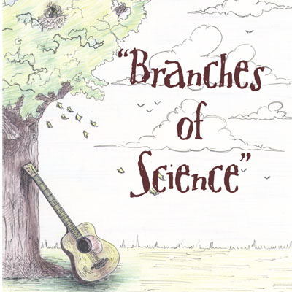
The two main branches of science are __________________________ & ___________________________.
_________________________ deals with the social life of people groups, including their geography, history, politics and economics.
_________________________ deals with the physical and biological world around us.
Study of living Organisms is called ___________________.
_______________Study of Plants
_______________ Study of animals

Study of the Physical World is called ________________
______________Study of the structure and behavior of substances
______________ Study of matter, energy and how they inter-relate.

Study of the Earth’s Structure is called ____________________.
__________________ Study of celestial objects
__________________Study of the crust of the Earth and other planets
__________________Study of the climate and weather
__________________ Study of the Oceans
http://www.ehow.com
SCORE:______ /15
The Nassau Guardian is hosting a comic strip creation competition and your class has been asked to participate. Choose two areas of science that you found interesting and create a comic strip that tells kids what that branch is about. Please email your completed comic strips to technostriker2013@gmail.com or ysamuels@cec.edu.bs. Below are a few free online comic strip creators that you can choose from:-
http://www.wittycomics.com/ http://superherosquad.marvel.com/create_your_own_comic
http://www.pixton.com/uk/ http://www.pikikids.com/
Due:- _______________________
Mark Scheme
Presentation :- /5 Content :- /10
Creativity :- /5

Total /20

