What are kingdoms?
To help us understand the number of living things on the planet, scientists organise them into groups, like 'the animals' or 'the plants'. This is called classification.
To start with, all living things are divided into large groups called 'kingdoms'.Scientists haven't quite agreed how many kingdoms there are, but many think that there are five: the monera, the protoctista, the plants, the fungi and the animals.
You probably know about the plants, animals and fungi (like mushrooms and yeast), but the monera and the protoctista may be new to you.
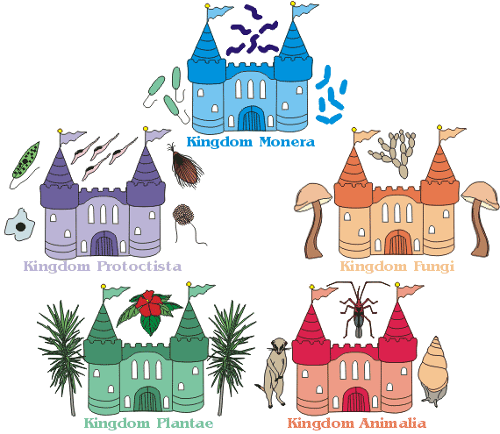

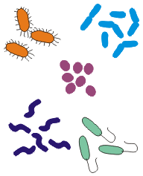
Kingdom Monera
Fact file
Name: Kingdom Monera
Type of organism: Bacteria
Numbers of species: We cannot begin to estimate
Where they are found: Everywhere - all imaginable habitats
Description: Bacteria are single celled organisms. Their cells have no nucleus. It is this characteristic that makes them different from any other form of life. They can be rod shaped, spiral shaped or round, with hairs (cilia) or tails (flagella) that let them move around. They reproduce by dividing - populations of bacteria can grow very quickly.
Need to know: Bacteria can live everywhere - deep in the ocean in complete darkness, in acid pools, in alkali lakes and even deep within the Earth's crust where no other life exists.

Kingdom Protoctista
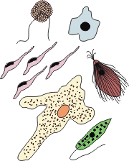
Fact file
Name: Kingdom Protoctista
Type of organism: Protists including single celled algae, slime moulds and amoeba
Numbers of species: Tens of thousands - but probably many more
Where they are found: Almost everywhere - in the sea, in freshwater, and on land
Description: Protists are single celled organisms, and like animal and plant cells they have a nucleus. There are many different types of protists - some that act like plants and make their own food, and some that are more like animal or fungal cells.
Need to know: Some protists cause disease. One protist, called Plasmodium, causes Malaria - a disease that causes thousands of deaths each year.

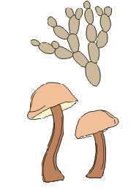
Kingdom Fungi
Fact file
Name: Kingdom Fungi
Type of organism: Fungi including mushrooms, toadstools and yeasts
Numbers of species: About 70,000
Where they are found: Almost everywhere - in the sea, in freshwater, and on land
Description: Fungi can be single celled organisms like yeasts, or multicellular (many celled), like toadstools mushrooms and moulds. Although they often look like plants, fungi do not produce their own food as plants do. Instead they live off dead or decaying plant or animal material.
Need to know: Fungi can be very useful - penicillin is made from moulds, yeast is used in baking and brewing, and we eat mushrooms on toast for breakfast!

Kingdom Plantae
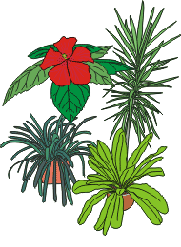
Fact file
Name: Kingdom Plantae
Type of organism: All plants, except for the simplest single-celled algae
Numbers of species: Around 400,000
Where they are found: Almost everywhere - in the sea, in freshwater, and on land
Description: Plants are multicellular (many celled) organisms. Their cells usually have thick cell walls, and they all have a pigment called chlorophyll that they use to produce their own food in a process called photosynthesis.
Need to know: There are many different groups of plants. Algae (like seaweed), mosses, ferns, pine trees, and flowering plants are different groups of plants, with different ways of living and reproducing.

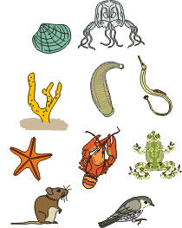
Kingdom Animalia
Fact file
Name: Kingdom Animalia
Type of organism: All animals, including you!
Numbers of species: 1,500,000 - but this is only a rough guess
Where they are found: Almost everywhere - in the sea, in freshwater, and on land
Description: Animals are multicellular (many celled) organisms. Their cells have no cell walls, and they do not produce their own food (as plants do).
Need to know: There are many different groups of animals, all living in different ways. Sponges, corals, worms, insects, crabs, snails, starfish, birds, mammals, reptiles, fish and amphibians are all animals. Explore Animal I.D. a bit more to find out how we classify animals.
SUPER SEARCHERS

Be a Super Searcher and see if you can find the answers to these ten questions in the section "Five Kingdoms of Living Things ".
Write your answers in the space provided.: When you have finished pass it to your teacher.

Question 1:
Living things are classified into 5 kingdoms. Can you name them?
We have started you off with the first letter.
A__________________
P __________________
F __________________
P __________________
B ___________________

Question 2: Can you complete this sentence?
The A___________ K___________ has animals with backbones: these are called v_____________; and animals without backbones: these are called i___________________.

Question 3:
Write down below 4 types of v______________________ animals.
1.
2.
3.
4.

Question 4:
Now write down 4 i_______________________ animals.
1.
2.
3.
4.

Question 5: Now try this one!
The plant kingdom is divided into 2 subgroups. See if you can complete the words below to show each subgroup.
1. F__________________ P____________.
2. N___ - F______________ P_______.

6: Green plants contain c__________________ so they can make their own food.

Question 7: This is quite difficult!
The green colour called c___________________ found in a plant's leaf, together with sunlight allows carbon-dioxide and water to be combined to make food.
This process is called p_________________________.

Question 8: Now see if you can make up these sentences.
Fungi are not green because they do not contain c__________________.
Fungi do not make their own food, they feed on v_____________ and a_________________ matter.

Question 9:
Protists are simple animals and are made up of o_____ c_________.

Question 10: Last one!!
Write down below an example of a protist.

___________________________________

