Numbers, numbers everywhere ,
There seems to be so many different types
That I can’t get them all clear!
Good Morning TechnoStrikers, I have a fact finding mission to send you on today.
I have gotten myself in a bind and I don’t know who else I can turn to. I was given this chart with number types and their meanings and I seem to have erased some of the data by accident.
Could you please help me to correct this chart by filling in the missing information.

Please record your findings using your best cursive handwriting.
Terms | Definition | Examples
Natural | ________________________________________________________________________________________________________
Counting | ________________________________________________________________________________________________________
Integers | ________________________________________________________________________________________________________
Positive Integers | 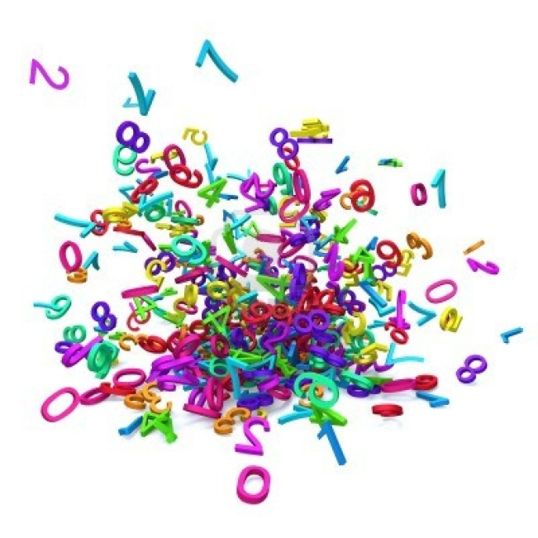  ________________________________________________________________________________________________________
Negative Integers | ________________________________________________________________________________________________________
Whole Numbers | ________________________________________________________________________________________________________
Odd Numbers | ________________________________________________________________________________________________________
Even Numbers | ________________________________________________________________________________________________________
Fractions | ________________________________________________________________________________________________________
Prime | ________________________________________________________________________________________________________
Composite | ________________________________________________________________________________________________________
Decimals | ________________________________________________________________________________________________________
Square Numbers | ________________________________________________________________________________________________________
Square Roots | ________________________________________________________________________________________________________
Factors | ________________________________________________________________________________________________________
Multiples | ________________________________________________________________________________________________________
Exponents | ________________________________________________________________________________________________________

Types of Numbers Worksheet
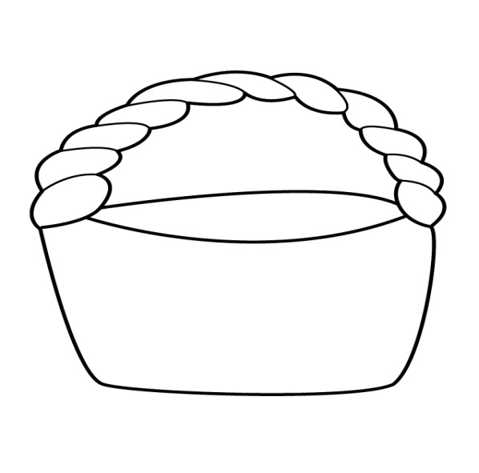
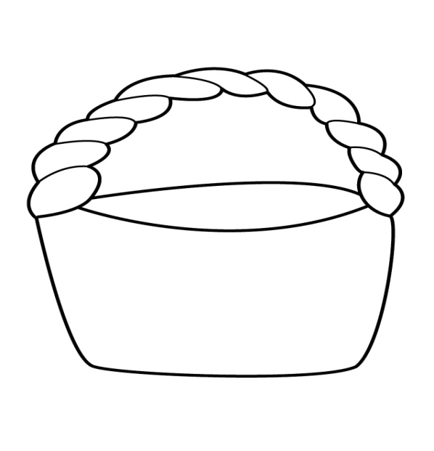
For each set of numbers below, please sort them into their correct baskets. (12)
44 65 79 3,462 12,761 890,654

Even
ODD

SCORE
/ 20
Identify the following numbers by writing the group that they belong to.( 8 )

- 2/4 ________________________________
- -9 _________________________________
- 0.46 _______________________________
- 0 _________________________________
- $\sqrt{49}$ _______________________________
- $\{1,2,3,4,……\}$ _______________________________
- $\left\{2,4,6,8,….\right\}$ ________________________________
- $3$⁴ _________________________________________

Composite
Prime
15 31 19 21 37 27

