Chorus
Wait, you’ve gotta make sure that your lab is safe
Before you make a measurement, scope out the space
Got your gloves pulled up, got your goggles on
Don’t want to be another lab experiment gone wrong
Go with goggles, go with the gloves!
Go without food, and spit out your gum!
Go safe! Go safe! And get into it
Go safe scientists, no accidents!
Verse I
You know the science lab can be a pretty dangerous place
You gotta wear safety goggles to protect your face
And just in case you still end up with stuff in your eye
You should know how to find the eyewash nearby
And as a matter of fact, know where the exits are too
‘Cause if a fire starts, you better know what to do
And you don’t have to be a hero, try to break the mold
Be sure to follow all directions and just do as you’re told
It reminds me of this time I was sitting in lab
Trying to work through the experiment and give it a stab
When my partner started grabbing chemicals from the shelves
Started mixing up some liquids with unusual smells
Before he could stop, it began to bubble up
In a couple of seconds he was in deep, deep trouble
So maybe mixing crazy potions didn’t go as he’d planned
He didn’t follow the directions and he burned his hand (ouch!)
Chorus

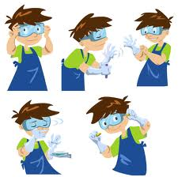
Verse II
It’s lab time and you’re ballin’, on top of things
Hypothesis made the call on what you want to see
But hold up, because it looks like you forgot some things
Before you pour, let me know what’s wrong with this scene
Your eyes are wide open to take in results
Or get blinded by all kinds of chemicals
They could splash up and mess up your complexion
So keep it hot, yo, and don those goggles
The same goes for your fingers, your hair, and your toes
No flip-flops, your kicks should have the tips closed
Your fingers should slip through the wrists of some gloves
No acid contamination on your palms
And your nose, you’ve gotta steer clear of the chemicals
Or they’ll burn your nostrils (and you kind of want those!)
Protect it, don’t smell it, just waft with me, waft with me
Don’t need no medics, just waft with me, waft with me
Hands over the flask, your nose hanging back
Keep your nostrils intact, just waft with me, waft with me
Chorus
Verse III
Hey, I think I really like this lab stuff
I’m gonna do it again tomorrow ’cause I can’t get enough
Of safely making crazy things happen, it’s fun
It’s amazing, I’ve seen the reactions, I’m done
You’re almost done man, can you tell me your plan
For what to do with all that toxic waste in your hand?
I just heard the bell ring, I’ve gotta think quick
I think I’ll wash it down the sink
Whoa, whoa, whoa
Hold on, bro, how do you know where that goes?
By tomorrow the sink will be starting to glow
Put the waste in the designated receptacle
And clean your station off before you take off, yo
“Put the caps on the bottles?”
Yeah, that’s right.
“Wipe the tabletop off?”
Yeah, that’s right.
“Run the flask under water?”
Yeah, that’s right.
You cleaned up real nice, see, and nobody died

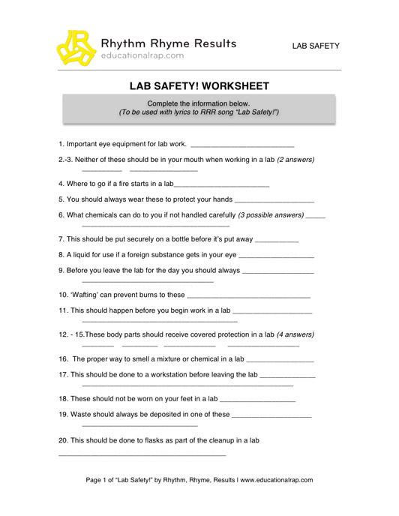
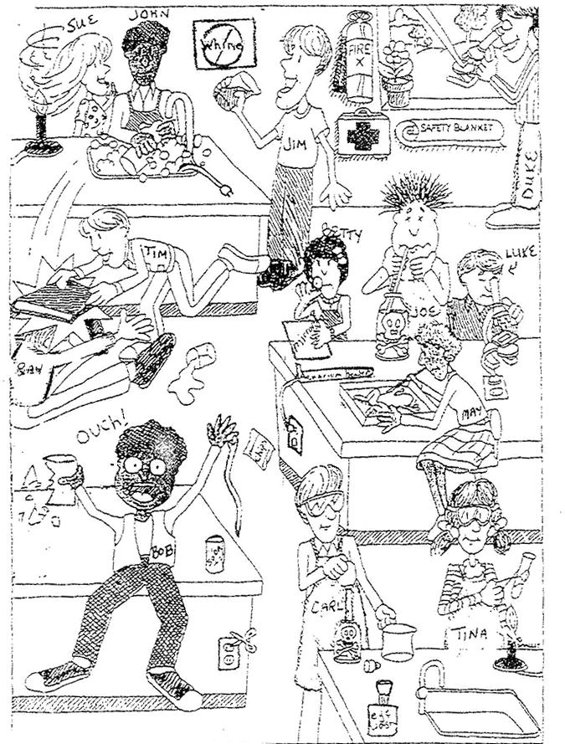

1. List 3 unsafe activities shown in the illustration and explain why each is unsafe (we will do this orally).
a. __________________________________
b. __________________________________
c. __________________________________
2. List 3 correct lab procedures shown in the illustration.
a. __________________________________
b. __________________________________
c. __________________________________
3. What should Bob do after the accident?
________________________________________________________________________________
4. What should Sue have done to avoid an accident?
________________________________________________________________________________
5. Compare Luke and Duke's lab techniques. Who is following the rules? __________________________
6. What are three things shown in the lab that should not be there?
a. __________________________________
b. __________________________________
c. __________________________________
7. Compare Joe and Carl's lab techniques. Who is doing it the correct way? _________________________
8. What will happen to Ray and Tim when the teacher catches them?
________________________________________________________________________________________________________________________________________________________________
9. List three items in the illustration that are there for the safety of the students in the lab.
a. __________________________________
b. __________________________________
c. __________________________________
10. What is Betty doing wrong?
__________________________________________________________________________________________________________________________________________________________________________

