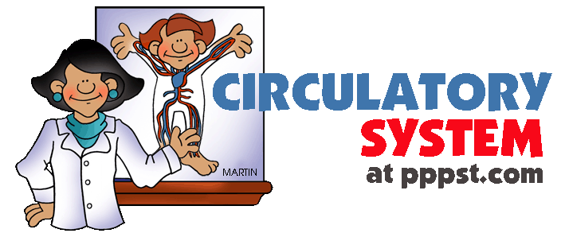

The main organ of the circulatory system is the heart. Its main job is to pump blood to every living cell in the body. The heart is divided into four chambers. The two upper chambers are called atrium and the two lower chambers are called ventricles. A partition separates the right side of the heart from the left side. This prevents the blood on the left and right chambers from mixing. This is important because the left side of the heart has blood rich in oxygen, but the right side has blood with very little oxygen. Blood is carried around the body in blood vessels called veins, arteries and capillaries.

Caring for your Circulatory System.
- Exercise every day to keep your heart strong. Exercise strengthens your heart by making it beat harder, which makes the heart muscles larger and able to push more blood with each “squeeze” or “beat”.
2. Keep germs out of your blood.
Wash cuts with soap and water.

3. Never touch someone else’s blood.

4. Eat healthy foods to avoid diseases such as hypertension and diabetes.

5. Do not ever smoke. Smoking narrows blood vessels and can cause high blood pressure.

***********************************************************
Did you give your friends valentines and little heart-shaped candies on Valentine's Day? Do you ever cross your heart when making a promise that you really, really mean? Or turn on the radio to hear a guy singing about his broken heart?
We see and hear about hearts everywhere. A long time ago, people even thought that their emotions came from their hearts, maybe because the heart beats faster when a person is scared or excited. Now we know that emotions come from the brain, and in this case, the brain tells the heart to speed up. So what's the heart up to, then? How does it keep busy? What does it look like? Let's find out.

Working That Muscle
Your heart is really a muscle. It's located a little to the left of the middle of your chest, and it's about the size of your fist. There are lots of muscles all over your body — in your arms, in your legs, in your back, even in your behind.
But the heart muscle is special because of what it does. The heart sends blood around your body. Theblood provides your body with the oxygen and nutrients it needs. It also carries away waste.
Your heart is sort of like a pump, or two pumps in one. The right side of your heart receives blood from the body and pumps it to the lungs. The left side of the heart does the exact opposite: It receives blood from the lungs and pumps it out to the body.

We Got the Beat
How does the heart beat? Before each beat, your heart fills with blood. Then its muscle contracts to squirt the blood along. When the heart contracts, it squeezes — try squeezing your hand into a fist. That's sort of like what your heart does so it can squirt out the blood. Your heart does this all day and all night, all the time. The heart is one hard worker!

Heart Parts
The heart is made up of four different blood-filled areas, and each of these areas is called a chamber. There are two chambers on each side of the heart. One chamber is on the top and one chamber is on the bottom. The two chambers on top are called the atria (say: ay-tree-uh). If you're talking only about one, call it an atrium. The atria are the chambers that fill with the blood returning to the heart from the body and lungs. The heart has a left atrium and a right atrium.
The two chambers on the bottom are called the ventricles (say: ven-trih-kulz). The heart has a left ventricle and a right ventricle. Their job is to squirt out the blood to the body and lungs. Running down the middle of the heart is a thick wall of muscle called the septum (say: sep-tum). The septum's job is to separate the left side and the right side of the heart.
The atria and ventricles work as a team — the atria fill with blood, then dump it into the ventricles. The ventricles then squeeze, pumping blood out of the heart. While the ventricles are squeezing, the atria refill and get ready for the next contraction. So when the blood gets pumped, how does it know which way to go?
Well, your blood relies on four special valves inside the heart. A valve lets something in and keeps it there by closing — think of walking through a door. The door shuts behind you and keeps you from going backward.

It's Great to Circulate
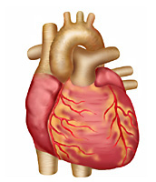
You probably guessed that the blood just doesn't slosh around your body once it leaves the heart. It moves through many tubes called arteries and veins, which together are called blood vessels. These blood vessels are attached to the heart. The blood vessels that carry blood away from the heart are called arteries. The ones that carry blood back to the heart are called veins.
The movement of the blood through the heart and around the body is called circulation(say: sur-kyoo-lay-shun), and your heart is really good at it — it takes less than 60 seconds to pump blood to every cell in your body.
Your body needs this steady supply of blood to keep it working right. Blood delivers oxygen to all the body's cells. To stay alive, a person needs healthy, living cells. Without oxygen, these cells would die. If that oxygen-rich blood doesn't circulate as it should, a person could die.
The left side of your heart sends that oxygen-rich blood out to the body. The body takes the oxygen out of the blood and uses it in your body's cells. When the cells use the oxygen, they make carbon dioxide and other stuff that gets carried away by the blood. It's like the blood delivers lunch to the cells and then has to pick up the trash!
The returning blood enters the right side of the heart. The right ventricle pumps the blood to the lungs for a little freshening up. In the lungs, carbon dioxide is removed from the blood and sent out of the body when we exhale. What's next? An inhale, of course, and a fresh breath of oxygen that can enter the blood to start the process again. And remember, it all happens in about a minute!

Listen to the Lub-Dub
When you go for a checkup, your doctor uses a stethoscope to listen carefully to your heart. A healthy heart makes a lub-dub sound with each beat. This sound comes from the valves shutting on the blood inside the heart.
The first sound (the lub) happens when the mitral and tricuspid valves close. The next sound (the dub) happens when the aortic and pulmonary valves close after the blood has been squeezed out of the heart. Next time you go to the doctor, ask if you can listen to the lub-dub, too.

Pretty Cool — It's My Pulse!
Even though your heart is inside you, there is a cool way to know it's working from the outside. It's your pulse. You can find your pulse by lightly pressing on the skin anywhere there's a large artery running just beneath your skin. Two good places to find it are on the side of your neck and the inside of your wrist, just below the thumb.
You'll know that you've found your pulse when you can feel a small beat under your skin. Each beat is caused by the contraction (squeezing) of your heart. If you want to find out what your heart rate is, use a watch with a second hand and count how many beats you feel in 1 minute. When you are resting, you will probably feel between 70 and 100 beats per minute.
When you run around a lot, your body needs a lot more oxygen-filled blood. Your heart pumps faster to supply the oxygen-filled blood that your body needs. You may even feel your heart pounding in your chest.
Try running in place or jumping rope for a few minutes and taking your pulse again — now how many beats do you count in 1 minute? _______________

Keep Your Heart Happy
Most kids are born with a healthy heart and it's important to keep yours in good shape. Here are some things that you can do to help keep your heart happy:
- Remember that your heart is a muscle. If you want it to be strong, you need to exercise it. How do you do it? By being active in a way that gets you huffing and puffing, like jumping rope, dancing, or playing basketball. Try to be active every day for at least 30 minutes! An hour would be even better for your heart!
- Eat a variety of healthy foods and avoid foods high in unhealthy fats, such as saturated fats and trans fats (reading the labels on foods can help you figure out if your favorite snacks contain these unhealthy ingredients).
- Try to eat at least five servings of fruits and vegetables each day.
- Avoid sugary soft drinks and fruit drinks.
- Don't smoke. It can damage the heart and blood vessels.
So now you know that your heart doesn't look like a valentine, but it sure deserves to be loved for all the work it does. It started pumping blood before you were born and will continue pumping throughout your whole life.

http://kidshealth.org/PageManager.jsp?lic=1&article_set=54036&cat_id=20607#
http://www.youtube.com/watch?v=LqhvmUEdOYY
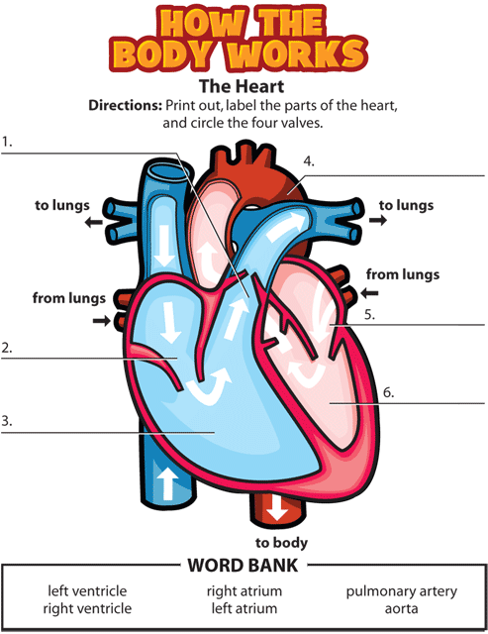

Class Project
Make a Stethoscope

Materials:
• Plastic hose
• Funnel

Directions:
Step 1: Connect the plastic hose to the funnel.

Step 2: Carefully place the other end of the plastic hose near your ear. Step 3: Place the funnel on a friend’s chest.
Step 4: Listen to your friend’s heart beat.

Step 5: Place the funnel on your chest, and listen to your own heart beat.

1.
4.
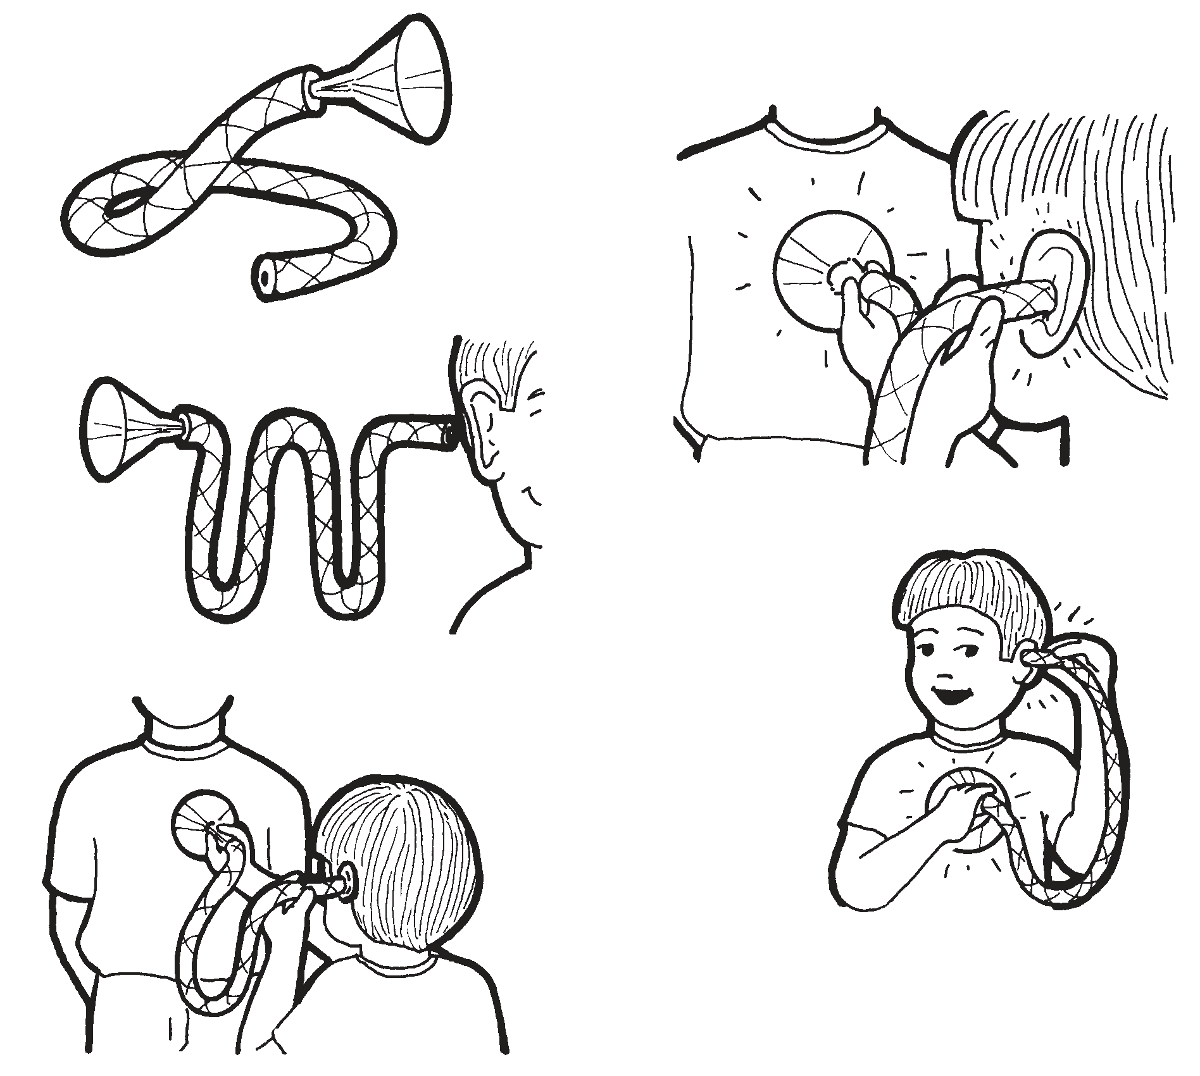

2.

5.
3.

CIRCULATION - Total _______/10
Top of Form
1. What does your heart do?
It pumps air around your body
It pumps blood around your body
It pumps blood to just your muscles
2. Which of these would make your heart beat the fastest?
Lying down
Sitting on a chair
Swimming
3. What does your pulse rate tell you?
How fast your heart is beating
How fast you are running
How old you are
4. Why does your heart beat faster when you exercise?
Because it gets excited
To get oxygen to your muscles more quickly
To make a louder noise
5. Veins carry blood...
towards the heart
away from the heart
inside the heart
6. James wants to become healthier. Which of these would NOT help him?
Regular exercise
Eating a healthy diet
Using the car more instead of walking
7. Blood moves round your body in special tubes called blood vessels. Which of these is NOT a blood vessel?
A vein
An artery
A ventricle

8. What happens to your blood when it reaches your lungs?
It picks up oxygen
It picks up carbon dioxide
Nothing
9. What is the most important reason why smoking cigarettes is bad for you?
Because cigarettes can burn your fingers
Because cigarettes can harm your heart and lungs
Because the smoke can get in your eyes
10. Which is the most important reason why you should NOT drink alcohol before driving a car?
Because you might need to go to the toilet
Because alcohol makes you less careful so you might have an accident
Because you might get stopped by the police

HOME WORK
Your School Science Club has launched an Ad campaign informing the general public on how to keep their heart healthy. In your assigned group choose on of the following methods to demonstrate at least 4 ways that individuals can keep their heart healthy.- Total

- A Skit/ Rap
- A Cartoon
- A Poster
Powerpoint Presentation-

